Spring Rally 2023

Sunday March 19th
Operating Hours 8:30 a.m.-5 p.m.
$10 off all lift tickets
Mid-Week Season Pass Holders are welcome to join us!!

Schedule of Events:
DJ and festivities begin at noon with DJ Jay Bird and a bounce house for kids
Obstacle Course (for kids ages 11 and under) 2 p.m.
Wacky Waterski (for adults 18 and over) 3 p.m.
Cardboard race (for all ages!!) 5 p.m.

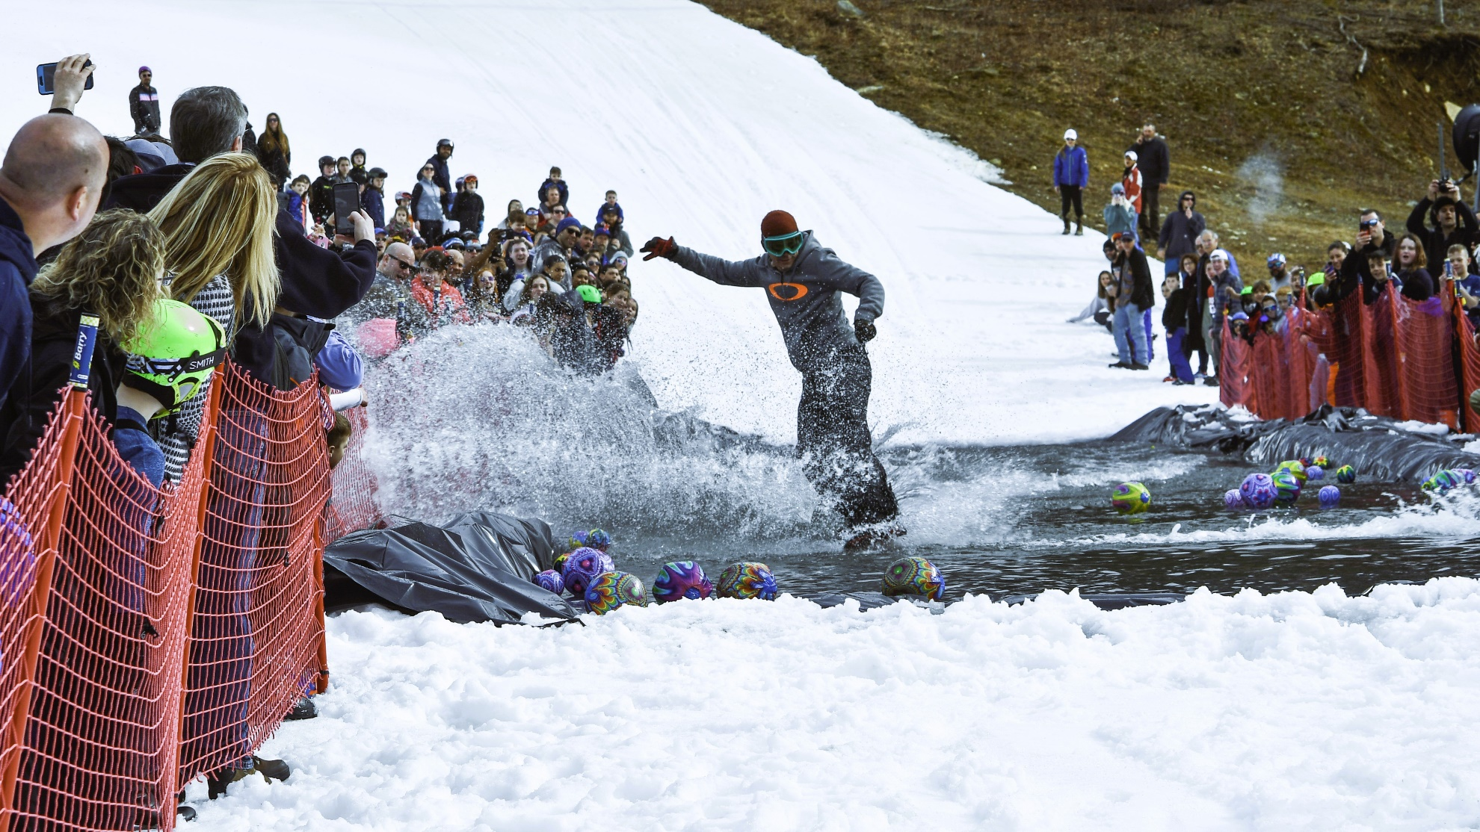
Sign-ups will be the day of the event in guest services
Anyone joining the Wacky Waterski, Cardboard Race or Obstacle Course will need to sign a waiver (if under 18 parent/guardian MUST sign)
Please visit website for cardboard race rules
Lots of games and prizes! This is THE event of the season!!!
